UNIT TEST DOCUMENT |  | Module Name | LANDING PAGE MODULE
Test Cycle No. | 1 | Module Name
Test Cycle No. | 1 | Component Name | LANDING PAGE
Date Tested |  | Type of System | Web Application
Pre-conditions | Desktop browser is open and the AgriX client web portal is available. User is signed out.
Action Description | Navigate to the AgriX landing page. Review the hero section, header navigation, calls to action, and footer. Click the available navigation links and confirm they open the expected pages or sections.
Verification Steps | Confirm the landing page loads without errors; the hero content, header, and footer are visible and readable; and each navigation link or call to action routes to the correct destination.
Test Scenario | Data  (Input Values) |  |  | Expected Results | Actual Results | Remarks
1 | Open the AgriX landing page. |  |  | The hero displays “AgriX Coffee Monitoring,” its storage-monitoring description, feature bullets, and the “Start Monitoring” and “Sign in” buttons. | 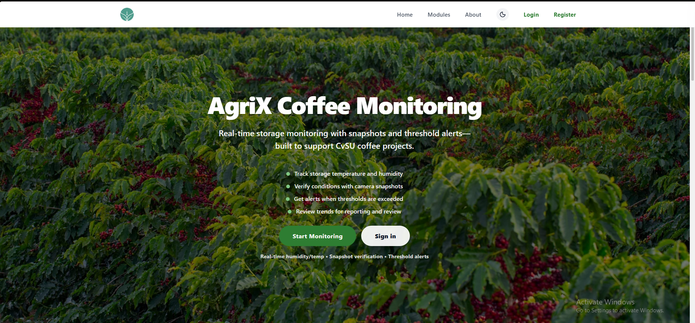 | PASSED
2 | Click Home, Modules, and About one at a time. |  |  | Each link navigates to the matching landing-page section. The header remains visible and usable. |  | Choose an item.
3 | Click Modules or scroll to the Modules section. |  |  | Module cards appear for the ESP32 Microcontroller Node, OV2640 Camera Module, Humidity and Temperature Sensing (DHT11), and Bean Moisture Monitoring. Each card shows its icon, title, and description. |  | Choose an item.
4 | Click About, then click Create an Account. |  |  | The About section shows the project description and goal. Create an Account opens the registration page. |  | Choose an item.
5 | Click Login, Sign in, and Register from the header or hero. |  |  | Login and sign-in open the login page; Register opens the registration page. |  | Choose an item.
6 | Click Start Monitoring on the hero section. |  |  | The button opens the intended monitoring page or prompts the visitor to sign in if monitoring requires an account.
7 | Review the four feature bullets on the landing page. |  |  | The page lists storage temperature and humidity tracking, camera snapshot verification, threshold alerts, and trend review.
8 | Click Modules in the top navigation. |  |  | The page scrolls to or displays the Modules section with all module cards visible.
9 | Click the moon icon in the header. |  |  | The page switches theme while keeping text, links, cards, and controls readable.
10 | Scroll to About the Project. |  |  | The section describes AgriX as a coffee monitoring platform supporting CvSU and explains its goal of making monitoring consistent across web and mobile.
11 | Scroll to the bottom of the page. |  |  | The footer displays the AgriX branding, “Coffee monitoring for CvSU,” and the Follow Us social icons.
12 | Resize the desktop browser to a narrower window and inspect the header. |  |  | The logo, navigation, theme toggle, Login, and Register controls remain visible and usable, or collapse into an accessible menu.
13 | Click Start Monitoring on the hero section. |  |  | The page reloads without errors and displays the landing page content correctly.
14 | Click the AgriX logo in the header. |  |  | The browser returns to the landing page’s Home section.

Prepared By | Administered/Performed By
____________________________  Signature over Printed Name | ____________________________  Signature over Printed Name

